Jacob Miller

Professor Sonstein

DSCI.623.01

18 October 2019

Midterm – Part 2 – Sample Queries and Executive Summary Report

*(NOTE: The following is an entirely fictional, somewhat cynical look at drug pricing and manufacturing. The year was 2017, shortly after the Epipen debacle…)*

**Grab**

At Pharma4All we pride ourselves above all else on making the cheapest possible drugs. We currently outsource the majority of our manufacturing to the lowest possible bidder, ensuring the patient pays the lowest out-of-pocket cost. We avoid auditing any suppliers or staffing extraneous employees, like a Quality Assurance department, as these would eat into the customer’s potential savings. Keeping money in the pocket of the patient is our mission, and we are willing to make any sacrifice to make that happen.

**Problems and Solutions**

The cost of prescription drugs continues to rise, as a result of stricter government regulations and higher manufacturing costs. As a company in the drug manufacturing business, Pharma4All can only control one of these two variables. Regulations will continue to tighten as more drugs hit the market, so we look to offset that by lowering the manufacturing costs wherever and whenever possible. With that in mind, Pharma4All is looking to expand its in-house manufacturing into a new, cost-effective, territory.

**Company Description**

Pharma4All is a contract manufacturing organization. We look to enter into contracts with other companies that wish to get their products manufactured at a reasonable price. If it is cheaper to outsource that manufacturing to a third-party, we will pursue that route. Any and all paths to producing economical treatments will be considered. Established earlier this year as a direct result of the outlandish price hike of the Epipen, Pharma4All vows to never price another patient out of a necessary treatment.

**Mission Statement**

Sacrificing it all to ensure no patient is priced out of a lifesaving or life-improving drug.

**Business Expansion**

Rationale

Regulations within the United States continue to tighten, which directly impacts the cost of manufacturing drugs domestically. As the government looks to make drug manufacturing more difficult, Pharma4All must direct more resources toward learning about and adhering to these regulations. Pharma4All has very limited control over these regulations, which subsequently get reflected in drug pricing. Any confrontation with the agencies will only result in further price hikes, as additional staffing and resources would need to be directed to the cause. We hope to combat the continual rise in price due to regulatory agencies by finding a new, cheap, location to build a manufacturing plant ex-United States.

Criteria for Expansion

As various locations were considered for the business expansion, four main criteria were considered:

1. Net national income per capita
2. Infant mortality rates per 1000 live births
3. Successful terrorist acts per year (success as defined by the Global Terrorist Database Codebook)
4. Educational expenditure as a percent of gross domestic product

Many countries were considered, with three countries ultimately reaching the final list: Israel, Japan and Mexico.

**Net National Income**1

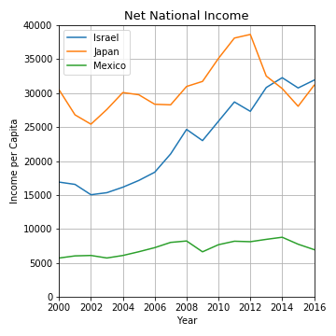

*Figure 1. Net national income per capita.*

Net national income per capita was considered for the obvious reason of paying competitive salaries at the plant. Note that competitive in this case is considered from both sides: Pharma4All must pay its workers enough to maintain a workforce, but they also must pay low enough salaries that it minimally impacts drug costs. Again, cost cutting is all for the ultimate sake of saving the patient money.

As can be seen in Figure 1, income has steadily increased in Israel since the year 2000. Japanese income has fluctuated quite a bit, rising from 2002 to 2012, before taking a sharp downturn, and actually falling below Israeli income in recent years. Finally, and most beneficial to Pharma4All, Mexican income has remained largely stagnant, at a rate far below the other two countries.

Based on this data from the turn of the century through 2016, one can expect Israeli and Japanese per capita income to continue to rise at a rate that far outpaces Mexican per capita income. For this reason, when considering a location that minimizes worker salaries, Mexico would be an ideal location to promote low cost manufacturing.

**Infant Mortality Rates**1

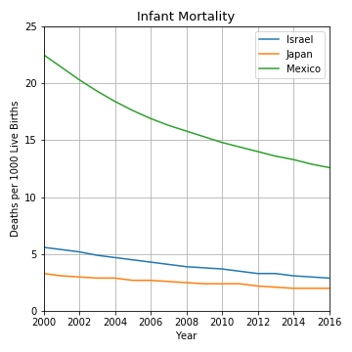

*Figure 2. Infant deaths per 1000 live births.*

The correlation between infant deaths and expanding manufacturing may not be as obvious as income but is still relevant to our analysis. Infant mortality is closely related to access to medicine and overall development and knowledge of the medical field within the region. Higher rates of death are associated with limited access to medicine and a medical field that is not as well developed as other countries. Therefore, Pharma4All’s company image could greatly be improved by providing low-cost medications to these areas in desperate need of medical advancement. Especially when considering the Epipen pricing disaster, providing economically priced drugs would paint a far better picture within the industry.

Once again, Mexico looks to be an ideal location for Pharma4All to expand into, with the intent of providing cheap medication to patients in need. While infant mortality has drastically improved in the timeframe studied, with nearly a 50% decline between 2000 (22.5 child deaths per 1000 live births) and 2016 (12.6 child deaths per 1000), it is still more than 4 times higher than Israel (2.9 child deaths per 1000) and more than 6 times higher than Japan (2 child deaths per 1000). In all locations, the infant mortality rate continues to improve as medical advances are made, and Pharma4All would support this trend wherever the expansion ultimately happens. However, Pharma4All would likely have the largest impact, and therefore the greatest improvement in public perception, by delivering cheap medication to patients – especially infants – in Mexico.

**Terrorism**2

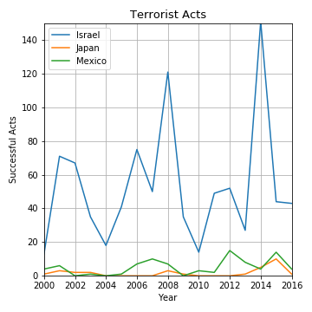

*Figure 3. Successful terrorist acts per year.*

When considering business expansion into a new region, especially with a business based on the model of underselling competitors – which can understandably agitate some in the industry – it is necessary to understand the political situation within a region. One metric that actually can be measured is the number of successful terrorist attacks within a country, as defined in the Global Terrorism Database Codebook3. We look specifically at successful attacks, because an unsuccessful attack was thwarted in some way, which could suggest a government which actually has control over the region – similar to a police officer catching a criminal as they are about to commit a crime. By looking only at successful attacks, we get a very good idea of how politically stable or unstable a country is.

Figure 3 shows Israel as a region which has very limited control over terrorist attacks within its borders, whereas Japan and Mexico both remain relatively constant with minimal attacks per year. For anyone paying attention to the news in the last 60-plus years, this picture of Israel (and the region at-large) comes as no shock, but the data also shows there has been no improvement in the most recent 20 years. Both Mexico and Japan show minor upticks since 2011/2012, so it will be important to watch what happens over the next several years, but both countries still rank well below Israel. If the decision to expand is imminent, Japan appears to be slightly more stable than Mexico – a small increase in 2015 appears to have mostly receded since then.

**Educational Expenditure4**

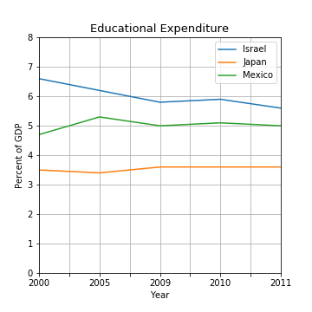

*Figure 4. Educational expenditure per year as a percent of gross domestic product.*

How much a country invests in its education system is a direct measure of how much it is investing in its future. It would benefit Pharma4All to expand into a country which invests in its youth and future, while at the same time balancing cheap labor. As education rises within a country, the workforce as a whole also tends to move towards more intellectual jobs, while cheap labor moves to other, less educated, regions. While this may be an over-simplification, Pharma4All must make decisions based on the data available.

When looking at Figure 4, it is important to note that the most recent available data is from 2011, whereas the other categories capture data as recently as 2016. However, some trends still become obvious when looking at the available information. For instance, Israel has pulled back its educational spending by a full percentage point (6.6% to 5.6% of GDP). On the other hand, Japan has remained nearly perfectly constant, only fluctuating between 3.4% and 3.6% of GDP. Similarly, while Mexico bounced around in the early 2000’s, it has largely hovered around 5% most recently. It does not appear that either Japan or Mexico has any intention of raising or lowering its educational spending, while Israel appears to be funneling its educational spending elsewhere. Everything else being equal, Mexico once again would be the best location based on the balance between educational spending and cheap labor.

**Conclusion**

Based off of all available data, Pharma4All should consider Mexico an ideal location for manufacturing expansion. Employee income in Japan and Israel is far too high, putting Mexico in the ideal financial range. The political instability in Israel also makes it a very unrealistic location, while terrorist attacks in Mexico (the only measurement we have access to) remain minimal year over year. Finally, in Mexico we can expect to have a positive impact on the region as cheap and affordable drugs get manufactured for those in need. For the aforementioned reasons, the recommendation is to explore Mexico as the next location for expansion.

**Additional Queries**

Should additional queries need to be run, it is as simple as loading up *Query_Script*. First, save the three datasets1,2,4 in the *Raw_Data* directory. Ensure both the *Raw_Data* directory and the *Query_Script* program are saved in the same directory. Then load *Query_Script* either from the command line or terminal. The program will walk the user through compiling the data files, if necessary. It will then ask the user which datasets they would like to look at or compare. The user then has the option of looking at a specific country, or looking at all available countries.

**References**

1. “*Infant Mortality, Fertility, Income*.” *Kaggle*, https://www.kaggle.com/burhanykiyakoglu/infant-mortality-fertility-income.
2. “*Global Terrorism Database*.” *Kaggle*, https://www.kaggle.com/START-UMD/gtd.
3. “*Global Terrorism Database Codebook: Inclusion Criteria and Variables*.” University of Maryland, October 2019, http://start.umd.edu/gtd/downloads/Codebook.pdf.
4. “*World University Rankings*.” *Kaggle*, https://www.kaggle.com/mylesoneill/world-university-rankings.